**Innovation/Approach**

1. Dupuis et al., Methods to produce induced pluripotent stem cell-derived

mesenchymal stem cells: Mesenchymal stem cells from induced

pluripotent stem cells- 2021 Aug 26. doi: [10.4252/wjsc.v13.i8.1094](https://doi.org/10.4252%2Fwjsc.v13.i8.1094) [1]

1. Describe the main current protocols used to differentiate human iPSCs into MSCs: MSC Switch, Embryoid Body Formation, Specific Differentiation, Pathway Inhibitor, and Platelet Lysat.
2. The MSC Switch method emerges as the predominant choice, with six method variants cited over 100 times (refer to Table 1). It appears to to be the least complex of the protocols, at the expense of, perhaps, increased variability of the obtained iMSCs

Relative frequencies of commercial media in 32 studies

Coating used to produce induce pluripotent stem cell-derive mesenchymal stem cells.

1. Jiaci Chen et al. Review on Strategies and Technologies for Exosome Isolation and Purification – 2022 Frontiers in Bioengineering and Biotechnology [2]
2. Review common exosomal separation techniques but also emerging technologies with better performance, simple and affordable such as microfluidic chip
3. Common exosome isolation technologies including ultracentrifugation (“gold standard”)

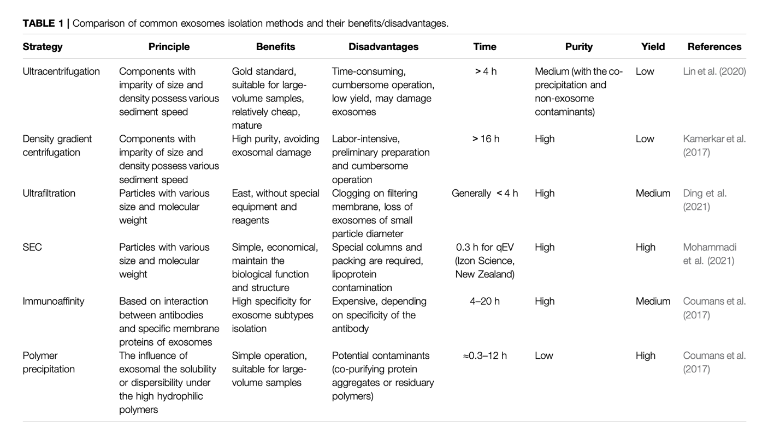

1. Description of microfluidic system which can isolate exosomes with high purity, minimizing contamination form other extracellular vesicles or protein aggregates. The process is more efficient and requires less time than ultracentrifugation techniques, it can be scaled up and the same system can be used for exosome modifications.

[1] V. Dupuis and E. Oltra, “Methods to produce induced pluripotent stem cell-derived mesenchymal stem cells: Mesenchymal stem cells from induced pluripotent stem cells,” *World J. Stem Cells*, vol. 13, no. 8, pp. 1094–1111, 2021, doi: 10.4252/wjsc.v13.i8.1094

[2] J. Chen *et al.*, “Review on Strategies and Technologies for Exosome Isolation and Purification,” *Front. Bioeng. Biotechnol.*, vol. 9, p. 811971, 2022, doi: 10.3389/fbioe.2021.811971